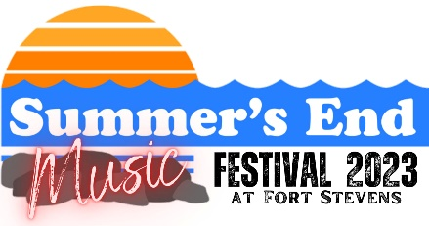

SPONSORSHIP AGREEMENT FORM

- Yes, I would like to be a sponsor for the Summer’s End Festival 2023
Please check the level of sponsorship at which you would like to participate:
    - $10,000 Presenting Sponsor
    - $7,500 Entertainment Sponsor
    - $3,000 Gold Level Sponsor
    - $1,500 Silver Level Sponsor
    - $500 Bronze Level Sponsor
    - $50+ Friends of the Festival
- We are unable to be a designated Summer’s End Festival sponsor this year, but would like to make a donation of $____________

Name: ________________________________________________________________________
Company/Business Name: ________________________________________________________
Address: ______________________________________________________________________
City: ________________________ State: ____________ Zip: __________________________
Telephone: _____________________________ Fax: _________________________________
Email Address: _________________________________________________________________
Payment Method (check one)
- Cash
- Check Check #____________
Please make checks payable to: Friends of Old Fort Stevens
100 Peter Iredale Road, Hammond, OR 97121
(For Sponsors wishing to use their logo please email your logo in a JPEG form at 300dpi to fortstevenssummersend@gmail.com)

